Universal Published Paper Review
Introduction
The Quinn Fluid Flow Model (QFFM) is a totally new and novel theory of fluid dynamics in closed conduits. The underlying intellectual property is owned by The Wrangler Group LLC (TWG). It has been developed from first principles and applies to fluid flow in both packed and empty conduits across the entire fluid flow regime including laminar, transitional and turbulent. The model has been validated by applying it to classic studies in both categories of flow embodiments and, in each case, to studies in all fluid flow regimes.
The QFFM can be expressed in two formats. The first format is a dimensional manifestation in which the measured differential pressure across the ends of a conduit is compared to the measured resultant flow rate of the fluid according to the relationships dictated by the model among the many independent and dependent variables pertaining to the physical fluid flow embodiment and pertaining to the fluid itself. The second format is a dimensionless manifestation, which we call Quinn’s Law, where all the individual respective contributions to the pressure drop/fluid flow relationship have been normalized between the model’s two entities, which we call the “Quinn reduced pressure” and the “fluid current” and which we denote with the symbols P_{Q} and Q_{c}, respectively.
Any given combination of the underlying variables prescribed by the QFFM will have a unique pressure drop at any given flow rate. Accordingly, the QFFM is capable of distinguishing between valid and invalid data. In particular, the QFFM can identify a mismatch between a practitioner’s statement of the values he/she claims to have measured or calculated for the QFFM variables and the practitioner’s measured flow rate and pressure drop. We consider any mismatch to be an invalid empirical result. It follows that for every invalid empirical result there is but one valid corrected result.
Before one can apply Quinn’s Law to any given empirical result that result has to be validated using the dimensional manifestation of the QFFM. This, in turn, is because one cannot normalize properly for all the individual respective contributions unless all the variables are correctly identified and their values are commensurate with the measured pressure drops and fluid flow rates. In general, we can state that since most of the underlying variables pertaining to a fluid flow embodiment are relatively easy to measure, the correction usually pertains to the more difficult-to-measure variables. In the case of a packed conduit, the problematical measurements include particle sphericity, average particle diameter and conduit external porosity, In the case of an empty conduit, the weak link in terms of measurability is the conduit’s inner wall roughness.
QFFM is a unique and powerful new tool in the arsenal of the fluid flow practitioner. In particular, when experiments are conducted in the transitional and/or turbulent regimes, the conventional methodology does not provide any reliable way to verify the accuracy of the results across a broad spectrum of Reynolds numbers. Thus, it is in these regions of the fluid flow regime that the QFFM will be shown to be most useful. In fact, it is a direct consequence from the statements contained herein that one needs only to measure pressure drop and fluid flow rate to evaluate the quality of one’s experimental technique. This new development in fluid dynamics means that those of us who have spent our entire lives doing fluid flow measurements can now enjoy the same benefits as our counterparts within the field of electricity and magnetism.

Paper Summary
We review here a published article in Energy Procedia 57 ( 2014 ) 633 – 642 entitled. Evaluation of pressure drop and particle sphericity for an air-rock bed thermal energy storage system by Trahan et al. For easy reference to the reader, we print here in its entirety the abstract in the paper.

Paper Abstract

The pressure drop of a packed bed thermal energy storage system with irregular shaped solid pellets and tank-to-particle diameter ratio of 10.4 is investigated. The bed height to diameter ratio is 2. The particle sphericity is calculated and used to compare pressure drop correlations to the measured values in the particle Reynolds number range of 353 ≤ Rep≤ 5206.

Data Analysis
TWG has performed an extensive evaluation of the above referenced published article utilizing the QFFM. We commence our evaluation of the paper with an in-depth analysis of the reported data.

In presenting our analysis herein we consider three distinct possibilities. They are presented herein in conjunction with our Figs A-1 through A-3. These three possibilities are derived based upon the reported values for particle sphericity (Ω_{p}) and packed conduit external porosity (ε₀). In each of the three scenarios we present a comparison of the measured data and the calculated values using (a) our Q modified Ergun type equation and (b) the classic Ergun equation. In each case we show two plots; one is an elaboration of Fig 2 in the paper and the other is a plot of the friction factor (f) derived from each of the two distinct equations plotted against the modified Reynolds number (R_{em}).

The QFFM recognizes the element of continuity dictated by the Laws of Nature and, accordingly, identifies values for the unique combination of Ω_{p} and ε₀ underlying the measured values of pressure gradient and flow rate reported in the experiment. If the measurement technique used by the authors is both accurate and precise, the reported values for these two variables will coincide with those identified by the QFFM. If not, there will be a discrepancy between the reported and calculated values generated by the QFFM. In addition, we stipulate that our plot representing the measured data is taken from the data plotted in Fig. 2 of the paper which we elaborate by the use of a second order polynomial relationship between the measured variable of mass fluid flux (μ_{s}^{m}) and pressure gradient (ΔP/L).

In our Fig A-1 herein, we accept the author’s representation that the value of Ω_{p} is 0.495. The QFFM returns a corresponding value for ε₀ of 0.469, which is in conflict with the reported value of 0.51for this variable reported in the paper. As shown in A-1, the Q modified Ergun type equation correlates the data perfectly and renders values of 268 and 1.54 for the Ergun type constants k₁ and k₂, respectively. It is also obvious from the plots that the classic Ergun equation, which treats these two variables as independent variables, does not correlate the measured data when the reported values of 0.495 and 0.51 are used as inputs.

In our Fig A-2 herein, we accept the alternate postulate of the value for Ω_{p} = 0.70 offered by the authors in the paper. The QFFM returns a corresponding value for ε₀ of 0.445, which is also in conflict with the reported value of 0.51 for this variable reported in the paper. As shown in A-2, the Q modified Ergun type equation correlates the data perfectly but renders values of 268 and 1.81 for the Ergun type constants k₁ and k₂, respectively. It is also obvious from the plots that the classic Ergun equation, which treats these two variables as independent variables, does not correlate the measured data when the reported values of 0.70 and 0.51 are used as inputs.

Finally, in our Fig A-3 herein, we take the opposite position and accept the author’s reported value for ε₀ = 0.51. The QFFM returns a corresponding value for Ω_{p} of 0.289, which is now in conflict with both the author’s postulated values of 0.495 and 0.70. As shown in A-3, the Q modified Ergun type equation correlates the data perfectly but renders values of 268 and 1.20 for the Ergun type constants k₁ and k₂, respectively. It is also obvious from the plots that the classic Ergun equation, which treats these two variables as independent variables, does not correlate the measured data when the reported values of 0.289 and 0.51 are used as inputs.

In our Fig. A-4 we show a table which contains a comparison of the values of the important variables contained in our analysis. It is informative to see from the table that the particle based Reynolds number (R_{ep}) is not an appropriate metric in as much as it completely ignores the element of continuity dictated by the Laws of Nature. In addition, please note that each of the three possibilities considered in our analysis generated a slightly different range of modified Reynolds number (R_{em}) for the same measured flow rates.

Fig A-1
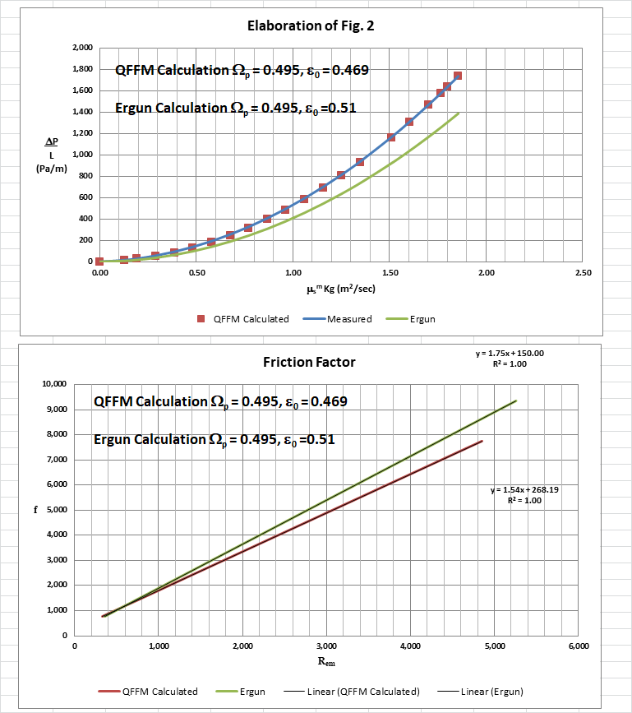
Fig. A-2
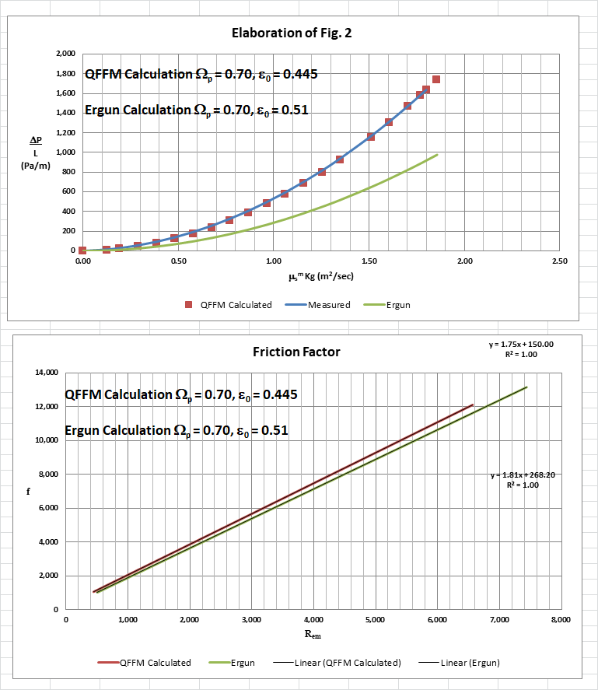
Fig. A-3
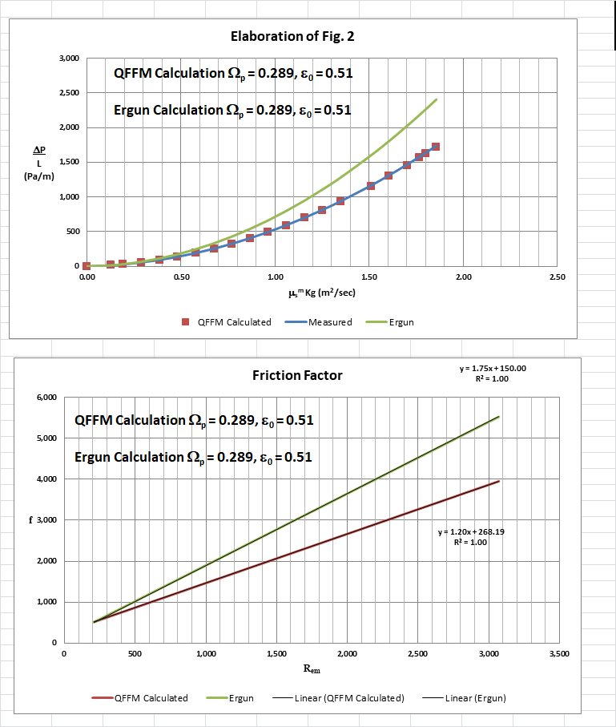
Fig. A-4

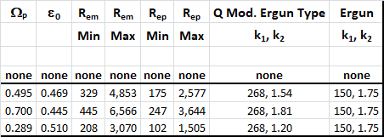

In Fig. B herein, we have provided our validation of the papers corrected data by a comparison of the data to Quinn’s Law. This normalized relationship is presented herein in the form of a plot of P_{Q} versus Q_{C,} which is the frame of reference of Quinn’s Law. This frame of reference is a transformation derived from the dimensional fluid flow relationship embedded in the QFFM. The relationship between these two unique reduced Quinn parameters is linear. However, we chose to present it as a log-log plot herein to provide emphasis at both extremes of the fluid flow regime. This plot is based upon both our own experimental data and independent accepted classical reference data which cover flow in both packed and empty conduits, over the entire fluid flow regime. (Note that the three distinct flow regimes of laminar, transitional and turbulent are clearly marked in the log-log plot.) As can be seen, the data reported in this paper, as corrected and as displayed in the form of a plot of P_{Q} versus Q_{C ,} lines up perfectly with Quinn’s Law.

Fig. B
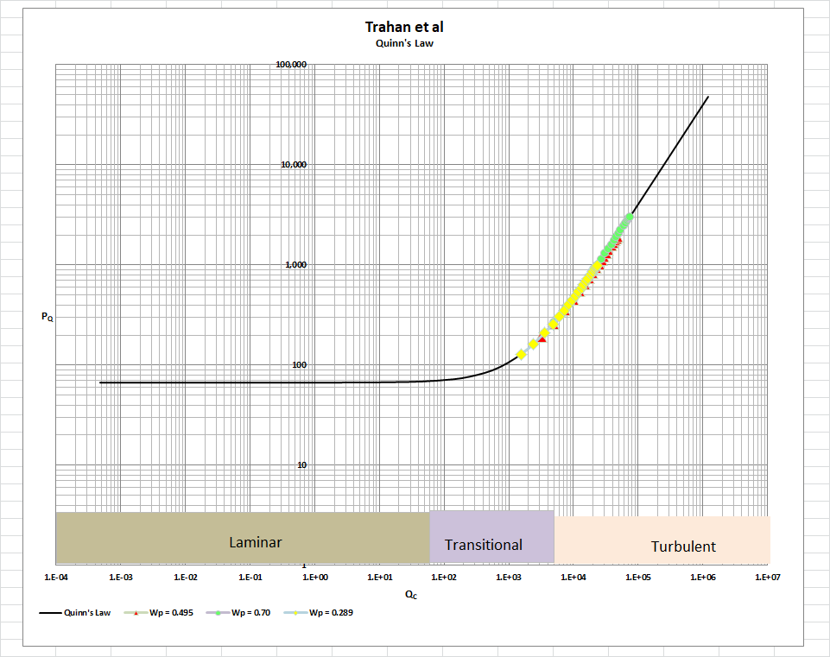

[Note: we do not herein provide the back-up for the validation of the plot of Quinn’s Law depicted in our Fig. B. For a description of the sources, both personal to TWG and from independent accepted classical references, on the basis of which the Quinn’s Law plot was validated, see the general introduction to this Universal Published Paper Review tab.
Conclusion.

We conclude that the measurement technique used by the authors suffered from deficiencies related to accuracy and precision which were undoubtedly exacerbated by the highly irregular nature of the particles used. In addition, the authors failed to properly apply the Laws of Continuity in their efforts to align their measured data with conventional empirical permeability equations. The authors erroneously relied, in part, upon the classic Ergun equation to try to reconcile their measured data which as we have shown herein cannot correlate the measured data under any one of the three possibilities considered in our analysis.

This is not surprising to us since we believe that the classic Ergun equation is simply invalid regardless of the particular flow regime considered and is shown to be increasingly discrepant as the range of modified Reynolds number increases and the external porosity increasingly deviates from the “sweet spot” value of 0.45. We do acknowledge, however, that just like in the case of a broken watch which returns the correct time twice per day, the classic Ergun equation may suggest a valid correlation in some isolated narrowly drawn circumstances in which the value of external porosity is close to 0.45. We suggest that the reader look to the conclusions expressed in our paper on the Ergun papers contained on this web site under the publications tab, for a brief summary of the underlying reasons why we believe this to be true. We also suggest that the authors look to a correlation study between particle-to-column diameter ratios in the case of spherical particles in order to decide the more appropriate value for ε₀ to accept for their measured values in this experiment.

Accordingly, there is a mismatch between the apparent measured values for spherical particle diameter equivalent, the reported values for column external porosity and the measured pressure drop and flow rates. This mismatch is only apparent and quantifiable in the context of the QFFM and, therefore, can only be corrected using this model. Accordingly, since the authors did not have access to Quinn’s Law when they wrote the paper, they could not have corrected the data before attempting to present it in the published paper. The inherent tendency to modify existing equations to correlate unsubstantiated empirical measurements has long since contributed to the confusion that exists in this field of study and has had a tendency to create the false illusion that these so-called conventional equations are of some value when, in reality, they are nothing more than invalid relationships.

Finally, although a detailed evaluation of the experiments reported in the paper under review, including an identification and quantification of the specific variables in each fluid flow embodiment which we claim the QFFM prescribes need to be corrected, is clearly within the capability of TWG, concerns about maintaining the confidentiality of the QFFM and Quinn’s Law – which, at this time, are still proprietary - dictate that such a development is premature.

